

ONE GROUP

TWO BRANDS

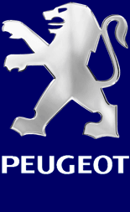

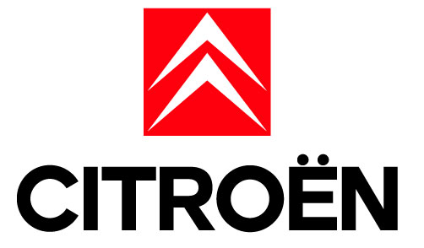
General information:

Name of the business: PSA (Peugeot Societé Anonyme)
Owners:
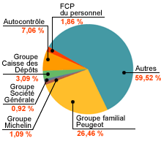

The buisiness organisation is : automobile
PSA isn’t listed on the Stock Exchange but it is listed on the Euronext
Jean Martin Folz runs PSA.
History of PSA : _1976 :fusion between Peugeot and Citroen. PSA holds 100% of the two automobiles companies.
_1978: acquisition of Chrysler Europe company.
_1988: creaton of Peugeot in Japan.
_1990: Peugeot is 100 years old.
_1992: cooperation between Peugeot and Renault..
_2000 and 2001:Peugeot is champion of the world of the rallies with 206.
_2002: Pierre Peugeot, the founder of the company, dead.
The sector: tertiary sector
Description of the main activity and product : Automobile construction
Description of the others activities and products :

_ Equipment car
_ Haulage Company and logistics
_ Banks PSA finances
_ Motor bicycle (scooters, auto-cycles, bicycles)
_Process Conception Ingenerate.
_Peugeot sport.

Locations of the headquarters:75 avenue de la grande armée – 75116 Paris

Location of the establishments :
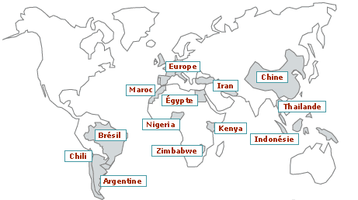

Final factories sites "final" PSA Peugeot Citroen ensure the final phases of manufacture of the vehicles (stamping, door-fitting, painting and assembly). At the exit of the assembly, the cars are directly availability of the marks.
- Aulnay (France) - Mulhouse (France) - Poissy (France) - Rennes (France) - Sevelnord (France) - Sochaux (France) - Buenos Aires (Argentina) - Kolin (Czech Republic) - Madrid (Spain) - Mangualde (Portugal) - Oporto Real (Brazil) - Ryton (the United Kingdom) - Sevel SpA (Italy) - Vigo (Spain) - Wuhan (China)

- Factories of mechanics and crudes the sites of "mechanics and rough" PSA Peugeot Citroen provide to the other factories of the Group the machine elements (engines, gear boxes and connections on the ground) and the "crudes" (foundry cast iron, foundry under pressure, forging mill and tools).
- - Asnières (France) - Caen (France) - Charleville (France) - French of Mechanics (France) - Metz (France) - Mulhouse (France) - Saint-Ouen (France) - Sept-Fons (France) - Sochaux (France) - Trémery (France) - Valenciennes (France) - Jeppener (Argentina) - Oporto Real (Brazil) - Xiang Fan (China)
- Sites of assembly the sites of assembly manufacture, under licence, the vehicles which are delivered to them in spare parts.
- - Bangkok (Thailand) - Bursa (Turkey) - Casablanca (Morocco) - Jakarta (Indonesia) - Kaduna (Nigeria) - Cairo (Egypt) - Los The Andes (Chile) - Mombasa (Kenya) - Mutare (Zimbabwe) - Teheran (Iran)

Statistics:
_Turnover: (en milliard d’euros):

1998 | 33.7
1999 | 37.8
2000 | 44.2
2001 | 51.6
2002 | 54.4

_Profits :

_Number of employees :

Automobile | 135 500
Equipment | 52 400
Logistics | 8 200
Finance | 2 200
Others activities | 2 500
TOTAL PSA | 200 800
In France | 125 000
In Others countries | 75 800

_Grow rate of the number of employees :

Date | Number of employees | Grow rate
30th June 2003 | 200 800 | + 1.11 %
2002 | 198 600 | + 1.11 %

_Value of the share, evolution of this value within the last year :
Peugeot SA : evolution - since 52 weeks : +0.47%
- since the start of the year : -0.15%
- out of 1 week : -1.30%

Description of the demand :

The consumers who are targeted are the people who need a car. There are different needs:
_For the work: an utility car (Peugeot expert)
_For family: a family car (806…)
_”for rich people”: a luxury car (607…)
_For townsmen: a small car (206…)

The demand change year by year. People wants small or big cars; rounded or rectangular cars. It depend of the fashion or if people travels more; or if they want small cars for cities.
It is a question of comfort.

The market is saturated because there is a lot of car in the world and today lots of people have got at least one car. It is because of this reason that PSA try to invent new car with new technology inside, they would the market to be expanding.

This is an International market

Description of the supply :

In France the market share of PSA is 30%.
In the world, there are many competitors like BMW, Audi, Toyota, Ford, Fiat, Renault…
There are all dangerous because they produce the same type of cars.

Check-up of the company :

PSA is the 2nd European car manufacturer with 15.5% of the market, it is the
company who had the best growth for 5 years.
There is much demand for cars and PSA try to make the lowest price to sell a
maximum of cars. The group wishes to put on the market some different and
innovating vehicles to satisfy all waiting: the cars have all new technologies, the group constructs car with a better integration in the environment and a reinforced security.
PSA has known a high increase in the number of workers: 1 100 engineers has
been engaged in 2002 and 17000 people have been divided into three centres of studies (Garenne-Doves, Vélizy, Belchamp).
The cars are made by production-line work. PSA is present all over the world and makes advertisement in a lot of countries, the advertisement policy is developed.

In the years to come, the demand for cars is going to increase so PSA is always looking for new technologies to improve their cars.
The competition is going to increase too, so PSA has to be competitive by selling a maximum of cars in the world.
To continue to be competitive, PSA has to invent new cars with new technologies.
Between 2002 and 2004, PSA has the project to present 25 new cars to face the demand and the competition. Till 2006, the group wants to invent 26 new cars.
Some of them will have a system of low consumption of petrol and hybrid
motorizations. But PSA wants at first to increase security, environment protection, comfort, originality and pleasure of driving. The new technologies let PSA face to the demand: in 2002, the group has made 6 new cars (Peugeot 206 SW, 307 SW, Citroen C3…)
PSA could set up in China in a few years: to be all over the world is a good way
for the company to sell a lot of cars

Personal Comments :

We choose this firm because she was interesting. She is listed on the Stock Exchange, she is one of the biggest automobile firm in Europe and in the world. This firm is present in automobile sport (rallies). Peugeot and Citroen have a very rich history.

We have divided the work. We have met ourselves to do this work in Simon's house. We have search information on www.psa.fr and on www.euronext.com for the value of the share

BACK

